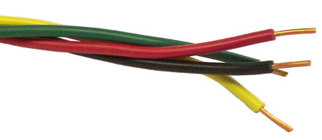
The Wire Award - Evidence Collecting Form 2025-26
Staff Name
School
South Glos, Swindon and Bristol and Wiltshire Schools
Widening Inclusion in Religious Education
Element | Place / Event / Date | Signature of person / evidence | Role of person/explanation
1. Visiting place of worship
Christian
Other faith/belief
2. Training event (CPD)
3. School based event - entering a competition or putting on an event

For elements 1 and 3 please submit scanned evidence of 3 pieces of pupil’s work or a link to the school’s website where work can be viewed.
https://www.natre.org.uk Spirited Arts or Spirited Poetry is a great National RE Art competition - evidence of entering this (not necessarily winning) is sufficient

